**Assignment 3: ex. 2 and 3**

**Exercise 2**

The advantage of a fully convolutional network, which only contains convolutional layers, is that it produces outputs for arbitrary input sizes. This enables a model to be trained on small images after which it can be applied to larger images such as whole slide images.1

The model that has been set up for this assignment consists of a convolution layer followed with a max pooling layer and once again a convolutional and max pooling layer combination. After this a flattening layer is incorporated to lead to a dense layer which is required as this is a classification problem, so the output needs to be of size 1 x 1 for each image in the batch.

Evaluation of this model with the provided validation set provides an AUC score of 0.8033125 and the following ROC curve:

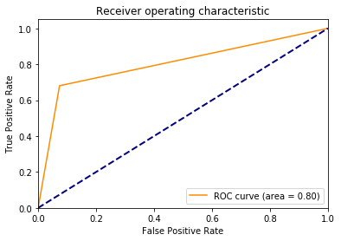

The code for this is provided in the same ZIP file with the name *Assignment3_2.py*

**Exercise 3**

Preparation of the results, which will be submitted to Kaggle, has been performed with the provided *kaggle_submission.py* file. Submitting these results provided an AUC score of 0.8760. This is a higher score compared to the AUC for the validation set which was 0.80. This might be due to the fact that more images were evaluated with the validation set compared to the test set which was eventually submitted. This gives more variety in the data and can thus lower the AUC score.

**References**

[1] Bejnordi, B. E., Veta, M., Van Diest, P. J., Van Ginneken, B., Karssemeijer, N., Litjens, G., van der Laak, J. A. W. M. ,the CAMELYON16 Consortium, 2017. Diagnostic assessment of deep learning algorithms for detection of lymph node metastases in women with breast cancer. JAMA, 318.